**Welcome to BIT**

[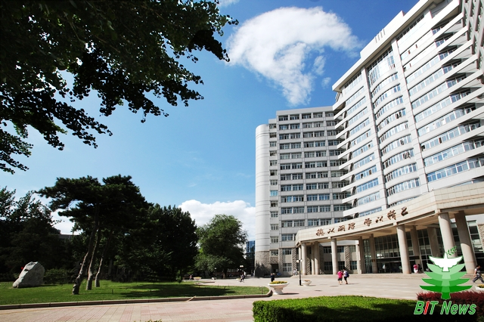](http://www.bit.edu.cn/images/content/2012-07/20120707161603831639.jpg)

Beijing Institute of Technology is one of the national key universities in China, an open, public, research-oriented university with a focus on science and technology. The 10th university to enter the 985 Project, which started in order to develop 39 Chinese universities that would seek to become world renowned universities.One of the first 15 universities to join 211 Project which established roughly 100 universities to cope with the challenges of the 21st century. Annual research fund in 2011 amounts to 160 million Euros ranking in the top 10 in China.

Received more than 130 national awards of science and technology over the past 30 years, ranking among the top 10 in China. According to the first national program evaluation from 2002 to 2004 by MOE, 1/3 of the programs in BIT were evaluated as national key programs.

BIT is one of the 1st universities to run a graduate school and one of the key universities supported by the central government in each Five-Year Plan since the foundation of the P. R. China. BIT receives considerable trilateral supports and endowments under the agreement signed by the Ministry of Education, the Commission of Science, Technology and Industry for National Defense, and the Beijing Municipal Government in September 2000.

BIT is now under the supervision of the Ministry of Industry and Information Technology.

**2013 Recruiting Plan for Outstanding Graduating Seniors (Teaching and Scientific Research Positions)**

**1. Positions Vacant: Teaching and Scientific Research Positions**

Consult the *2013 Recruiting Plan for Outstanding Graduating Seniors (Teaching and Scientific Research Positions).* for more details.

**2. Objects**

 Outstanding graduating seniors from domestic and overseas famous universities (Post-doctorate is included).

**3. Requirements**

① The cultivate method applicants have received should be full-time system cultivating and assignment are managed by government. A doctor's degree or an official academic credentials is needed. What's more, the university where applicants got your first degree should be top universities among the world or universities in "985 project".

②Domestic doctoral graduates (Post-doctorate is included) should be students from universities which take their majors as national key subjects in principle.

③ Age of applicants had best be under 32. For exceptional post doctorates and doctoral graduates who are associate professors in some professional skills, the age can be extended to 35.

④ applicants should have good English abilities in listening, oral English, reading and writing. Also, after a short-term cultivation applicants must have the abilities to teach bilingually.

⑤ Academic perspective and research ability are needed. Moreover, the researches applicants are making should be prediction and it is better to have some innovative accomplishments.

⑥ Applicants should be healthy in both mind and body.

⑦ Applicants should have good sense of teamwork and will of cooperation. Political thoughts and academic morality should reach the request as teachers.

⑧ Applicants' condition should meet the certain requirements employing units set.

**4. Method of Application**Please log in the graduates recruiting system of BIT (<http://bitrs.bit.edu.cn/rs/zhaopinbys.jsp>) for application form. Then print the "examination form for newly employed teachers" and fill in the personal information. When it is done, send it to the following address with personal certification of qualification:

Mr. XX, XX institute,

Beijing Institute of Technology, No. 5, south street, Zhong Guan-cun, Haidian District, Beijing. China 100081

"Applicant for Teaching and Scientific Research Positions" should be indicated in the application form.

Qualification certifications as below are required (not limited to those):  
1. Copies of scholarship certifications for all learning phases, which are qualified by related countries.

2. Copy of identity card.

3. Copies of certifications of English level.

4. Recommendation letters written by well-known experts in certain fields. (Must be original copies) the number of the letters should be no less than two.

5. Grade report of the last record of formal schooling. (Original copies)

6. Copies of thesis abstract.

7. Copies of representative thesis. (Periodical title page, catalog and complete text are all required.)

8. Copies of testimonials.

9. Copies of other qualification explanations.

Returned graduates should provide "certification of returned students" offered by education department in Chinese foreign embassies and "certifications of scholarship" offered by service center of studying aboard in ministry of education additionally.

Post-doctorates should provide certifications which can certify that one have finished the research in postdoctoral research institute, and copy of credentials of postdoctoral.

**5. Deadline**

June 2013（November for Post-doctorates and Returned graduates.）

**6. Special explanations**

1. Targeted-area students and target recruitment students are not acceptable.

2. Employed personnel must bring relevant scholarship certifications that are qualified by nations, employment pass (Allocation recommendation letters for post-doctorates) and relative qualification explanations. Those materials must be original copies.

3. Human agency system will be applied to other newcomers except for those outstanding graduates in 2013.

**7. Personnel policies consulting**

Contact Person: Wang Chuanmin

Tel: 010-68914546

Fax: 010-68913013

E-mail: [renshichu@bit.edu.cn](mailto:renshichu@bit.edu.cn)